AstroSage Analysis

Problem Statement:
AstroSage has received a ₹1 crore investment to improve its call center operations. The goal is to analyse historical call data, performance metrics, and market trends to determine how best to allocate this investment. The objective is to enhance operational efficiency, customer satisfaction, and profitability through data-driven decisions on staffing, technology, training, and process improvements.

Data Description:
The AstroSage dataset contains detailed records of customer interactions with astrologers across call and chat services. The data captures customer behaviour, service usage patterns, financial transactions, and performance metrics of astrologers. Each row represents a single customer session (call or chat), and the columns describe various attributes of that session.

The dataset includes the following types of information:

1. Basic Session Identification

These fields uniquely identify each record:

_id – Unique identifier for each record.

statementEntryId – Identifier used for statement.

CallSid – Unique identifier for call sessions.

2. User Information

user – Alphanumeric user ID assigned to the customer.

uid – Numeric user identifier.

isWhiteListUser – Indicates whether the user is whitelisted (true/false).

region – Geographical region of the user.

3. Astrologer Information

guru – Astrologer’s unique ID.

guruName – Astrologer’s display name.

gid – Astrologer ID in numeric format.

4. Consultation Details

consultationType – Type of consultation (Chat or Call).

website – Platform used (e.g. GuruCool, etc.).

FreeCall – Indicates if the call was free (true/false).

FreeChat – Indicates if the chat was free (true/false).

queue – Indicates whether the session was queued.

5. Chat Specific Fields

chatStatus – Status of the chat (Incomplete, Failed,etc).

chatStartTime – Timestamp when the chat began.

chatEndTime – Timestamp when the chat ended.

chatSeconds – Total duration of the chat in seconds.

timeDuration – Additional duration field related to chat timing.

6. Call Specific Fields

callChannel – Channel used for call communication.

callIvrType – IVR type used during the call.

callStatus – Status of the call (Connected, Failed, Missed, Busy, etc.).

userCallStatus – User-side call connection status.

astrologerCallStatus – Astrologer-side call connection status.

userOnCallDuration – Duration of the call from the user's side.

astrologerOnCallDuration – Duration of the call from the astrologer’s side.

7. Timestamp Fields

CreatedAT – Date and time when the session was created.

UpdatedAt – Date and time of last update to the session.

8. Financial Information

amount – Amount charged to the user.

astrologersEarnings – Amount paid to the astrologer.

netAmount – Final revenue retained by AstroSage.

RefundStatus – Refund eligibility or status (Refunded, No-refund, Processing).

9. Customer Satisfaction

rating – User’s rating for the session.

10. Unknown Data

v – Version key.

Tasks:
Objective Questions:

- What is the total no. of tables present in the data?
Ans:
35 attributes and after cleaning there are 42 attributes (columns) which
I have used to create pivot tables and dashboard.
- What is the total no. of attributes present in the data?
Ans:
35 attributes.
- The data consists of some inconsistent and missing values so ensure that the data used for further analysis is cleaned.
Ans:
To clean the data, I followed these basic steps:
Step 1: Removed duplicates
- Checked _id column.
- Removed repeated records if any appeared more than once.

Step 2: Fixed date and time formats
- Converted CreatedAT, chatStartTime, chatEndTime into proper Date-Time format.
- Created: CreatedDate, CreatedTime, UpdatedDate, UpdatedTime.
Created: ChatStartDate, ChatEndDate, ChatStartTime, ChatEndTime.
- This ensures dates work correctly.

Step 3: Handled missing values
- Kept rows where small values were missing
(like duration = 0 when the call failed or filled it with N/A for some).

Step 4: Cleaned text columns
- Used TRIM to remove extra spaces.
- Used PROPER to for texts.
- Standardised categories like “Call”, “Chat”, etc.

Step 5: Converted number columns
- Made sure columns like amount, rating, duration were numeric.
- Removed text or symbols if any.
Additional:
- Filled missing chat_status values with “Call Used” where the consultation type was Call
- Replaced empty cells with “N/A” for clarity
- Derived new columns from createdAT: date, time, day, month, year, hour
- Created chat_minutes from chat duration
- Added operational_cost column for cost analysis
- Applied conditional formatting:
- Highlighted N/A values in red
- Used color scale for rating column
- Highlighted Call entries in consultation type for easy identification

- What is the change in daily call volume day by day and also find the average daily call volume.
Ans:
Daily call volume was calculated by grouping call records using the date column derived from createdAT.
A Pivot Table was used to count total calls per day.
The average daily call volume was calculated using the AVERAGE function.
The average daily call volume is:
250 calls per day
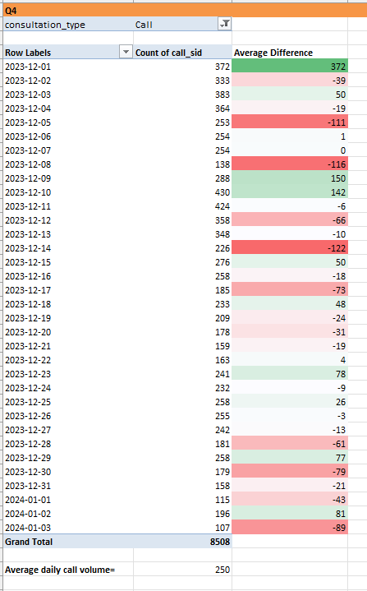
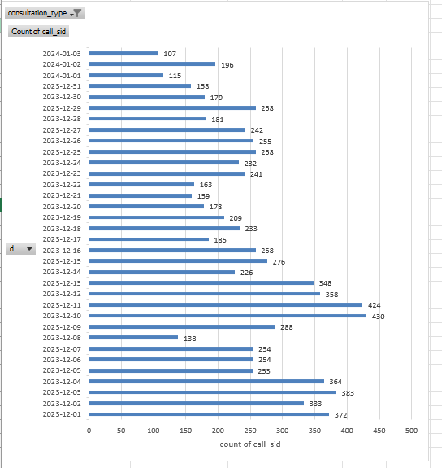
- Which months experienced the highest and lowest call volumes?
Ans:
I grouped the dates by Month in a Pivot Table and counted the total calls for each month. This identified which month had the highest and lowest call volumes.
December had the highest call volume with 8090 calls, while January had the lowest with 418 calls.
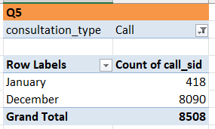
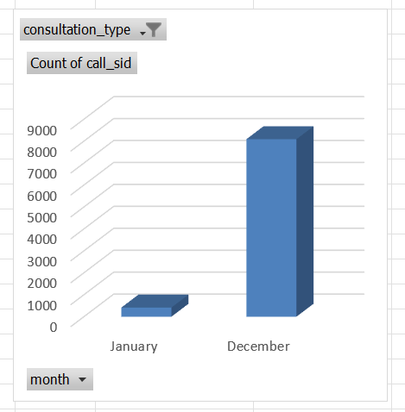

- What is the total operational cost for that month?
Ans:
The total operational cost was calculated by grouping call records by month and summing the operation cost column using a Pivot Table. The analysis shows that December incurred the highest operational cost at 85,949.78 due to higher call activity, while January recorded a significantly lower operational cost of 4,692.82. This indicates that operational expenses are closely linked to call volume and agent utilisation.
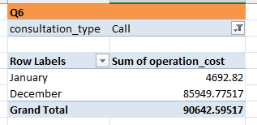

- What is the average number of calls handled per agent per day?
Ans:
To calculate the average number of calls handled per agent per day, only Call records were considered. A total of 8,508 calls were handled by 131 agents over 34 operational days. The average was calculated by dividing total calls by the product of total agents and total days, resulting in 1.9 calls per agent per day.
So round if 1.9 is 2, its 2 calls per agent per day.
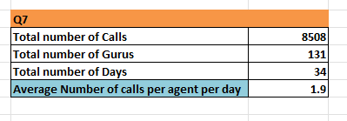
- How many repeat callers are there, and what percentage of total calls do they represent? (Changes from Feedback)
Ans:
To identify repeat callers, the dataset was first filtered to include only call records.
A Pivot Table was created using u_id as rows and Count of call_sid as values. Users with a call count greater than one were classified as repeat callers.
Based on this analysis, there are 1,278 repeat callers out of 3,632 total unique callers. Therefore, 35.19% of users are repeat callers.
Although repeat callers represent only 35.19% of total users, they account for 4,879 repeated calls out of 8,508 total calls, indicating that repeat users contribute a disproportionately higher share of overall call volume.
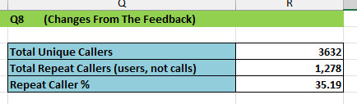

- What are the total sales generated by the call centre for each product category?
Ans:
To calculate total sales by product category, the dataset was filtered to include relevant consultation types. A Pivot Table was created using the website (source) column as rows and netAmount as values summarised by sum.
The analysis shows that the App generates the highest revenue (₹125,216.79), followed by Gurucool (₹88,719.93). The total sales generated by the call center amount to ₹213,936.72.
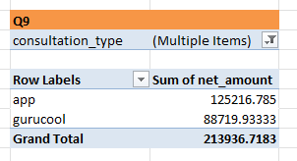 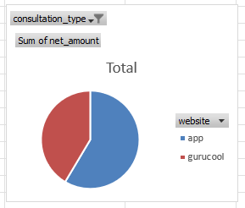
- How many calls were made for each user ID and guru ID?
Ans:
To determine the number of calls made by each user and handled by each guru, the dataset was first filtered to include only Call consultations. Two separate Pivot Tables were created.
In the first Pivot Table, u_id was placed in the rows and call_sid was counted to identify the number of calls made by each user. In the second Pivot Table, guru_id was placed in the rows and call_sid was counted to identify the number of calls handled by each guru.
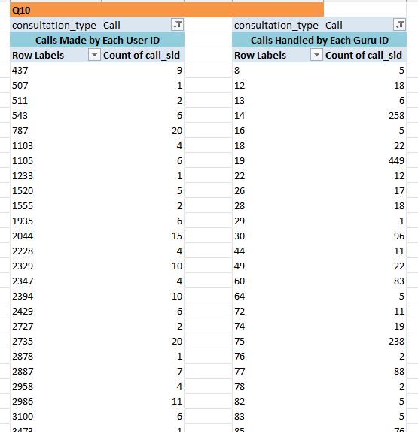
Counting… in the excel sheet in pivot section as Q10.

- What is the correlation between call duration and customer satisfaction?
Ans:
The correlation between call duration and customer satisfaction was calculated using the CORREL function by comparing call duration and rating values for call consultations.
The resulting correlation value is 0.0548, which indicates a very weak relationship between the two variables.
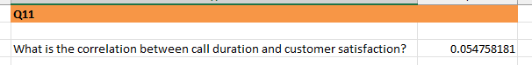

- Which guru has the highest and lowest customer satisfaction scores?
Ans:
To identify the highest and lowest customer satisfaction scores, the dataset was analysed using a Pivot Table by grouping records based on guru name and calculating the average rating for each guru.
The analysis shows that Astro Pujaa Rai has the highest average customer satisfaction score of 7.5, indicating strong and consistent user satisfaction. On the other hand, Tarot Rittika has the lowest average rating of 0, indicating poor customer satisfaction and a need for immediate performance improvement.
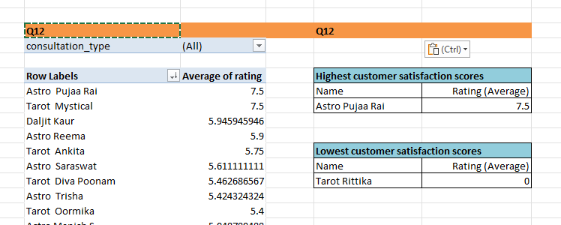
- What is the average customer satisfaction score by month?
Ans:
The average customer satisfaction score by month was calculated using a Pivot Table by grouping consultation records based on the derived month column and calculating the average of customer ratings.
The analysis shows that:
- December recorded an average customer satisfaction score of 2.95
- January recorded a lower average score of 2.68
.
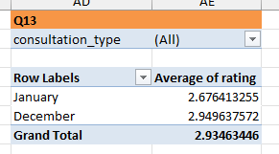
- How many categorical columns are there in the data?
Ans: There are 15 categorical columns.
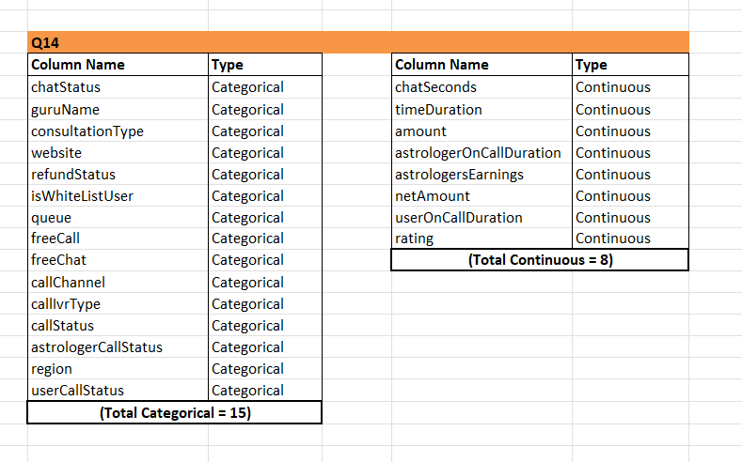

Subjective Questions:

- Should the investment be used to hire more agents, improve training programs, or upgrade call center technology? (Changes from Feedback)
Ans:
A) Hiring More Agents (Based on Guru-wise Performance Analysis):
To evaluate the need for hiring more agents, guru-level performance was analysed using average customer ratings per guru (g_id).

A Pivot Table was created with g_id as rows and Average of Rating as values. The analysis shows that guru ratings vary widely, ranging from as low as 1.0 to as high as 7.5, with an overall average rating of 2.93 across all gurus.

A Several gurus have consistently low average ratings (below 3), while only a limited number of gurus maintain high ratings above 4. This uneven distribution indicates inconsistent service quality across agents.

Insight:
The wide variation in average ratings suggests that some gurus may be overburdened or lack adequate support, which negatively impacts customer satisfaction.

Conclusion:
To improve service consistency and reduce workload pressure on existing gurus, a portion of the investment should be used to hire additional agents, especially during peak hours, to balance call distribution and improve average ratings.
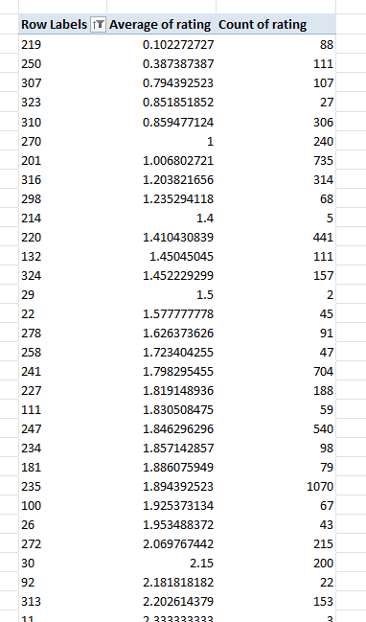

Counting… in the excel sheet in 1)Subjective QA section as
“(Changes From The Feedback)” (1)

B. Improve Training Program (Based on Average Call Time and Ratings)

To assess training requirements, Call consultations were analyzed by calculating average call duration (user_on_call_duration) and average rating for each guru.

A Pivot Table was created using g_id as rows, with:
- Average of user_on_call_duration
- Average of Rating

Key Observations:
- Average call duration varies significantly across gurus, ranging from near 0 minutes to over 400 minutes.
- Average ratings also vary widely, from as low as 1.0 to above 5.5.
- The overall average call duration is 35.45 minutes, while the overall average rating remains low at 2.93.

Some gurus have long call durations but still receive low ratings, indicating inefficient call handling. Others manage shorter or optimal call durations and achieve better ratings.

Insight:
Longer call duration does not necessarily result in higher customer satisfaction. The mismatch between call time and ratings highlights gaps in communication skills and problem resolution.

Conclusion:
The investment should focus on structured and targeted training programs to improve call efficiency, communication quality, and consistency in service delivery. Training low-performing gurus can significantly improve overall
customer satisfaction and repeat usage.

*Screenshot attached below*
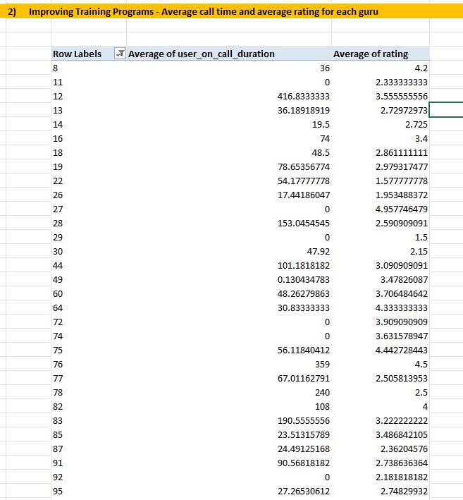

Counting… in the excel sheet in 1)Subjective QA section as
“(Changes From The Feedback)” (2)

C. Upgrade Call Center Technology (Based on Call vs Chat Status Comparison)

To evaluate the need for upgrading call center technology, call and chat session statuses were compared using Pivot Tables and pie charts.
i) Call Status Distribution (Call Consultation):
- Completed calls: 3,450
- Busy calls: 1,270
- No-answer calls: 1,728
- Failed calls: 1,185
- Incomplete calls: 875
- Total calls: 8,508

The call completion rate is 40.55%, meaning 59.45% of calls are not successfully completed due to busy, no-answer, failed, or incomplete statuses.
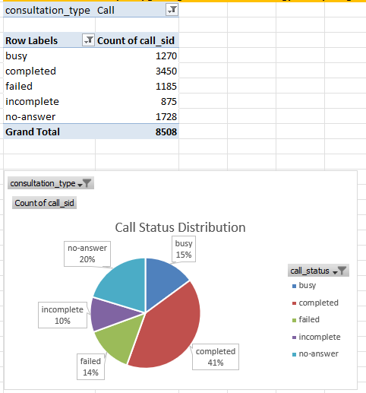

ii)Chat Status Distribution (Chat Distribution):
- Chat sessions show significantly fewer failures and more stable handling compared to calls.

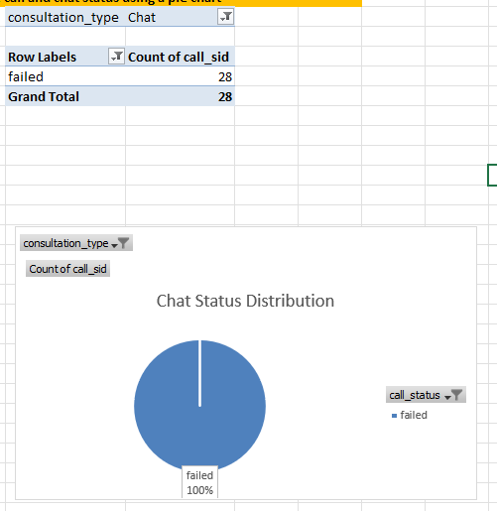

Insight:
The high proportion of unsuccessful call attempts indicates that the current call infrastructure struggles to handle peak traffic efficiently, while chat performs better due to queue handling and system stability.
Recommendation:
To reduce call failures and improve customer experience, the investment should be used to:
- Upgrade call routing and load balancing systems
- Introduce backup or alternate call service providers
- Implement AI chatbots to handle basic queries and reduce agent load

Final Recommendation
Based on the analysis:
- Technology upgrades should be prioritized to improve the low call completion rate (40.55%).
- Training programs should be implemented to address low average ratings (2.93) and inconsistent call handling.
- Selective hiring of additional agents during peak hours can further reduce workload pressure and improve service quality.

- What are the potential risks of each investment option (hiring, training, technology upgrades), and how can they be mitigated?
Name the chart/spreadsheet function you will use for solving the problem.

Ans:
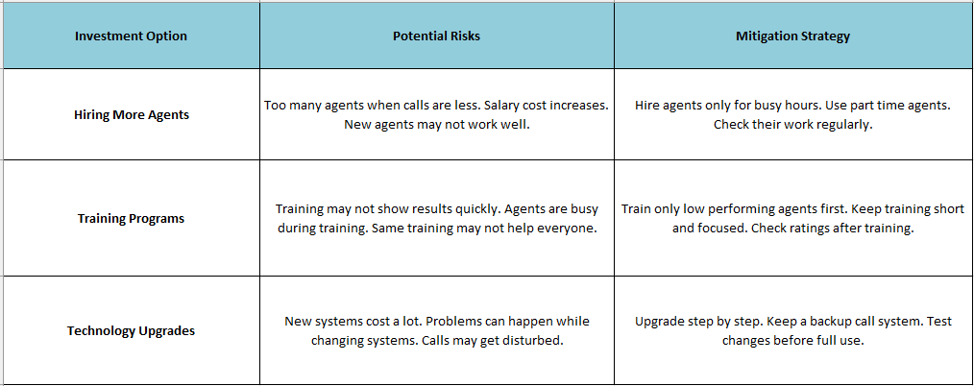

Each investment option has some risks, but they can be managed with the right approach. Hiring more agents can increase costs and lead to extra staff during slow periods, so agents should be hired mainly for busy hours or on a part-time basis. Training programs may not show quick results and can reduce agent availability during training, so training should be short and focused on low-performing agents, with progress checked through ratings. Upgrading call center technology can be expensive and may cause temporary issues during system changes, but these risks can be reduced by upgrading in steps, keeping backup systems, and testing changes before full use.

- How does AstroSage's call center performance compare to AstroGuru's average call volume, customer satisfaction, and agent performance?
Will you use any aggregation function or a visualization here to solve the problem?
Ans:
1: Call Volume Analysis:
The call center receives an average of 250 calls per day, as calculated using daily call volume. This shows strong demand for call consultations and indicates that the platform has a steady flow of users.
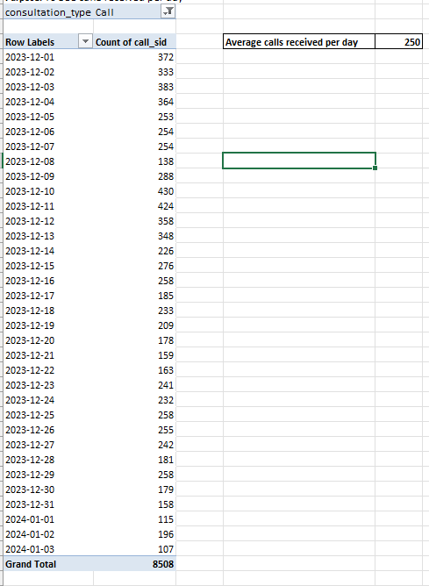
2: Call Completion Performance:
Out of a total of 8,508 calls, only 3,450 calls were completed, resulting in a call completion rate of 40.55%. This means that nearly 59.45% of calls were not completed due to busy, failed, incomplete, or no-answer statuses. Compared to an efficient industry setup, this completion rate is low and directly impacts customer experience.
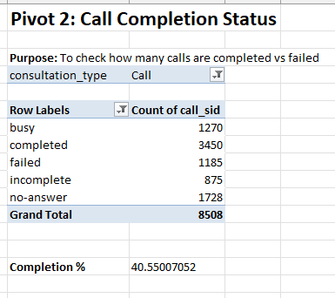
3: Customer Satisfaction Comparison:
The average customer ratings by consultation type show:
- Call: 3.5
- Chat: 2.69
- Complimentary: 4.5
Although Call services have a higher rating than Chat, the overall satisfaction level is still moderate. The low completion rate plays a key role in keeping call ratings from improving further

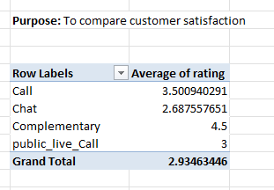
4: Revenue Contribution Analysis:
Call consultations contribute the largest share of revenue:
- Call net income: ₹168,442.03
- Total net income: ₹213,987.32
- Percentage of Call income: 78.72%
This confirms that Calls are the primary revenue source for the company.

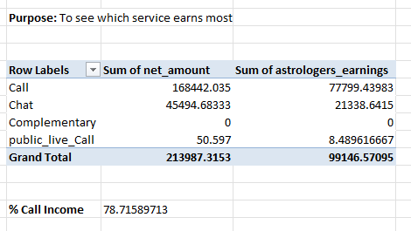

5: Relationship Between Agent Earnings and Company Income:
The correlation between astrologers’ earnings and company net income is 0.995, which indicates a very strong positive relationship. This means that when astrologer performance improves, the company’s income also increases almost proportionally.
=CORREL(range of astrologers_earnings, range of net_amount)
=0.995

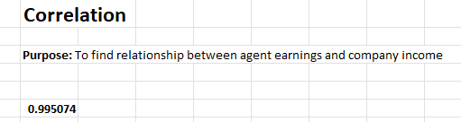

- How can the call center improve its handling of peak call periods to ensure high customer satisfaction?
Mention the functionality you will use for giving the suggestions, will it be any aggregated function or a visualization?
Ans:
To understand peak call periods, the number of calls received per day and per hour was analysed using Pivot Tables with the COUNT function.

From the daily call analysis, it is observed that 10th and 11th December 2023 recorded the highest number of calls, irrespective of call status. However, on these peak days, only around 40% of calls were completed, while the remaining calls were marked as busy, failed, incomplete, or no-answer. Out of 8,508 total calls, only 3,450 calls were completed, indicating heavy pressure on the system during peak periods.

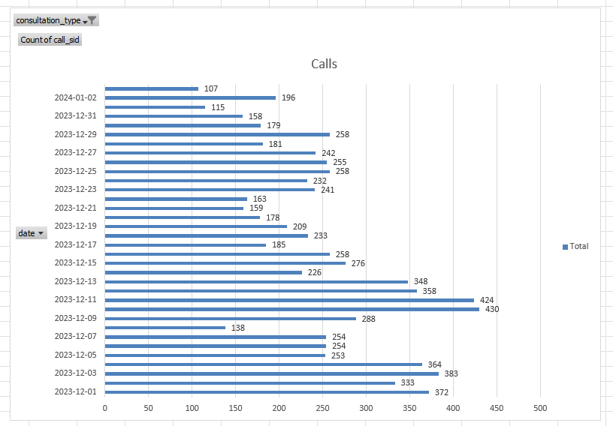

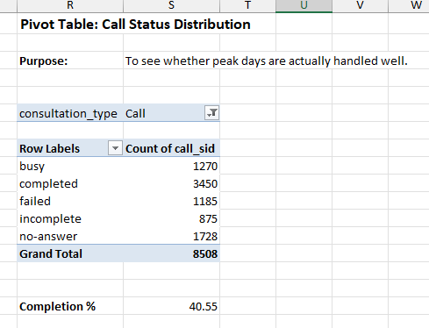

The hourly call distribution further shows that calls peak during morning and afternoon hours, when most users book and connect with Astro Gurus.

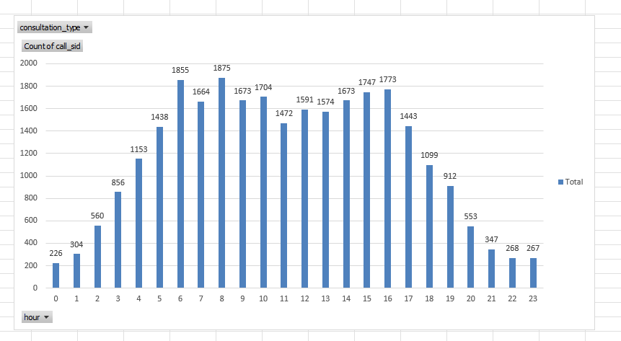
Hourly Call distribution which shows the peak hours

Actions Based on Analysis:
- Assign more agents during peak hours identified from hourly call data
- Plan shift timings based on peak days and hours
- Hire or allocate agents specifically for high-demand time slots
- Improve call routing and availability to reduce busy and no-answer cases

Conclusion:
By using aggregated functions like COUNT and visualisations such as bar and column charts, peak call periods can be clearly identified. This helps in better workforce planning, reduced call failures, and improved customer satisfaction.

- Based on historical data, what strategic initiatives should be prioritized to improve efficiency and customer satisfaction? (Changes from Feedback)
Ans:

Approach Used
Historical call volume, call status, customer ratings, consultation type, and website/source data were analysed to identify key operational gaps and customer experience issues. Strategic initiatives were proposed based on observed trends and performance metrics.

Strategic Initiatives:

1. Upgrade Call Center Technology:
- Only 40.55% of call consultations are completed, while 59.45% result in busy, no-answer, failed, or incomplete statuses.
- Chat consultations show more stable handling and fewer failures.

Initiative:
Upgrade call routing, load balancing, and queue management systems. Introduce AI chatbots to handle basic queries and reduce call congestion, especially during peak hours.

2. Improve Training Programs for Gurus:
- Overall average rating across all consultations is 2.93, indicating low customer satisfaction.
- Guru-wise analysis shows large variation in average ratings (ranging from 1.0 to 7.5).
- Many gurus have long call durations but still receive low ratings, highlighting inefficient call handling.

Initiative:
Implement structured training programs focused on communication skills, faster issue resolution, and consistency in service delivery. Provide targeted training for low-performing gurus based on rating and call duration analysis.

3. Focus on High-Impact Platforms and Services:
- GuruCool accounts for 20,225 out of 28,027 users, but has the lowest average rating (2.72).
- Call and Chat consultations, which handle most users, have lower ratings compared to Complimentary sessions.

Initiative:
Improve user experience on the GuruCool platform by optimizing interface performance and reducing technical issues. Apply best practices from high-rated platforms and consultation types to improve satisfaction in high-usage channels.

4. Optimize Agent Capacity During Peak Hours:
- Daily and hourly call volume analysis shows clear peak periods with high call load.
- High call volume during these periods contributes to busy and no-answer call statuses.

Initiative:
Introduce shift-based scheduling and hire additional agents for peak hours to distribute workload evenly and improve call completion rates.

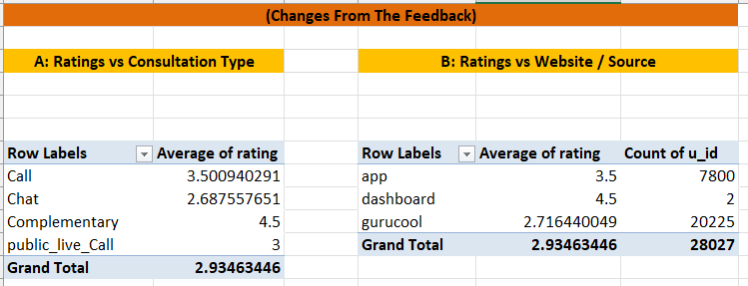

Conclusion
Based on historical data, the organization should prioritize upgrading call center technology, followed by targeted training programs and peak-hour workforce optimization. Improving platform-level experience on high-usage channels like GuruCool can further enhance customer satisfaction and operational efficiency.

- What can be the key factors contributing to high customer satisfaction scores, and how can these be leveraged to improve overall performance?
What is the basis for the suggestions? And mention how you decided if the satisfaction score affects the ratings. (Changes from Feedback)
Ans:
Approach Used:
To identify the factors influencing customer satisfaction, the analysis was carried out using Pivot Tables by comparing average ratings against multiple variables:
- Call duration
- Website / source platform
- Consultation type
The satisfaction score was measured using average user ratings, and patterns were observed across these factors.

A. Call Duration vs Ratings:
Purpose: To check whether longer call duration leads to higher customer satisfaction.
Using a Pivot Table with:
- Rows → Guru ID
- Values → Average of call duration, Average of rating

Observation:
- The overall average call duration is 35.45 minutes.
- The overall average rating is 2.93.
- Gurus with moderate call durations generally show higher ratings (above 3.5).
- Extremely long or very short call durations do not consistently result in higher ratings.

Insight:
Longer calls alone do not guarantee better satisfaction. The quality and clarity of interaction matter more than duration.

*Screenshot attached below*

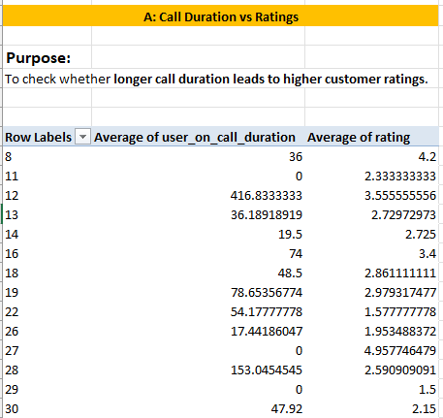

Counting… in the excel sheet in 6)Subjective QA section as
“(Changes From The Feedback)” (A)

B. Website / Source vs Ratings:
Purpose: To understand how platform experience affects customer ratings.

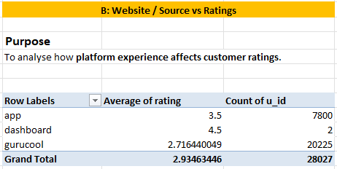

Insight:
- The App platform performs better than Gurucool in terms of ratings.
- Gurucool, despite having the highest user volume, has the lowest average rating (2.71).
This indicates that platform usability and experience strongly impact satisfaction scores.

C. Consultation Type vs Ratings:
Purpose: To identify which consultation type delivers better customer satisfaction.

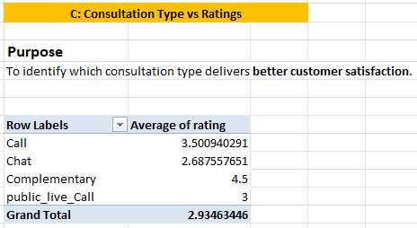

Insight:
- Complementary consultations receive the highest satisfaction (4.5).
- Chat consultations have the lowest average rating (2.69).
- Call consultations perform better than chat, but still leave room for improvement.

Conclusion & Recommendations
- Customer satisfaction is influenced by interaction quality, platform experience, and consultation type, not just call duration.
- Improving training for chat handling, enhancing Gurucool platform usability, and adopting best practices from high-rated consultation types can significantly improve ratings.
- Since higher ratings are linked to better user retention and repeat usage, focusing on these factors will directly improve overall performance and customer satisfaction.

- How should the call center balance the workload among agents to ensure optimal performance and avoid burnout?
Mention your approach and spreadsheet function for the answer.
(Changes from Feedback)
Ans:
Approach Used:
To analyse workload imbalance among agents (Astro Gurus), Pivot Tables were used to evaluate:
- Number of calls handled by each guru
- Average calls handled per guru (benchmark)
- Call distribution across hours to identify peak-time pressure
This helped identify whether workload is evenly distributed or concentrated among specific gurus.

A. Identifying Workload Imbalance Across Gurus:
A Pivot Table was created with:
- Rows: Guru Name
- Values: Count of call_sid
- Filter: consultation_type = Call

Key Observations:
- Total call records analysed: 8,508
- Some gurus handled extremely high call volumes, for example:
  - Astro Shalini – 1,060 calls
  - Tarot Gauri – 497 calls
  - Astro Brijesh – 342 calls
- Many gurus handled very few calls (1–10 range)

Insight:
Call workload is heavily skewed, with a small group of gurus handling a disproportionately large number of calls, while many remain underutilised.
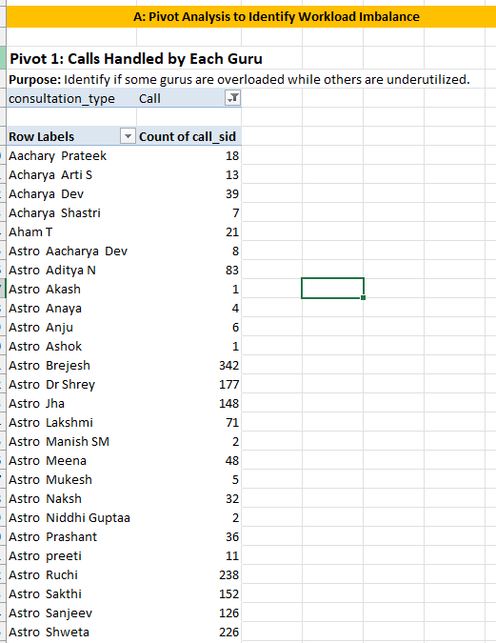
Counting… in the excel sheet in 7)Subjective QA section as
“(Changes From The Feedback)” (1)
B. Benchmarking Average Calls per Guru:
To understand fair workload distribution, the average calls per guru were calculated.

- Total Calls (Call only): 8,508
- Total Astro Gurus: 131

Average Calls per Guru:
8508 / 131 = 64.95 = 65 calls per guru

Interpretation:
- Gurus handling much more than 65 calls are overloaded
- Gurus handling much fewer than 65 calls are underutilised

Insight:
The imbalance confirms that workload is not evenly distributed, increasing burnout risk for high-load gurus.

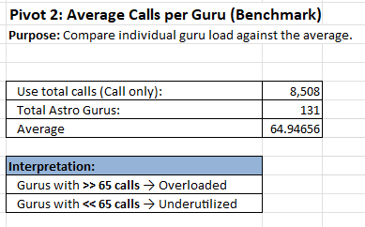

C. Peak Hour Pressure Analysis:
A Pivot Table was created to analyze call volume by hour:
- Rows: Hour
- Values: Count of call_sid
- Filter: consultation_type = Call

Key Findings:
- Peak call volume occurs between 6 AM and 5 PM
- Highest pressure hours:
  - Hour 8 → 660 calls
  - Hour 10 → 605 calls
  - Hour 7 → 551 calls
Insight:
Peak hours cause time-based workload spikes, leading to repeated overload on the same set of available gurus.

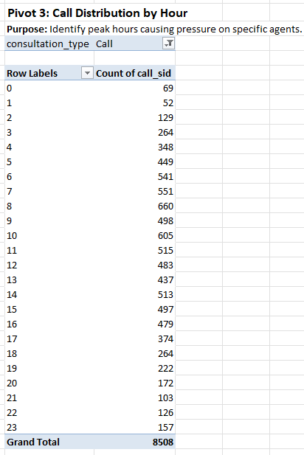

Final Insights:
- Workload is unevenly distributed, with few gurus handling most calls.
- Peak-hour demand intensifies agent pressure.
- Overloaded gurus are more likely to experience burnout, affecting service quality and customer satisfaction.

Recommendations:
- Smart Call Routing:
Distribute calls based on current guru load instead of simple availability.
- Shift-Based Scheduling:
Allocate more agents during peak hours to reduce pressure.
- Workload Rotation:
Balance call assignments across underutilized gurus.
- Chatbot & Automation Support:
Reduce call volume by handling basic queries through AI/chat.
- Regular Monitoring:
Track calls per guru weekly to prevent long-term overload.

Conclusion:
By benchmarking average calls per guru and analyzing peak-hour pressure, clear workload imbalance was identified. Implementing smarter routing, better shift planning, and automation will help evenly distribute workload, reduce burnout, and maintain consistent service quality.

- What new technologies or tools could be implemented to enhance call center operations and customer service?

Ans:

- IVR + improved telephony / carrier fixes: Reduces failed/incomplete calls.
- AI-based auto-routing (skills & load-based): Routes to available, skilled gurus to reduce wait & balance load.
- Callback / virtual queue system: Lets customers keep place in line without holding. Reduces abandon.
- Workforce Management (WFM) tool: Shift planning and shrinkage handling for peaks.
- Call recording + speech analytics (NLP: Auto-detects bad calls, sentiment, QA.
- Real-time dashboard + alerting (Power BI / Excel + Power Query): Ops visibility.
- Chatbot / NLP assistant: Handles common queries, reduces simple load on gurus.
- CRM integration: Context on repeat users to personalise calls.
- Quality monitoring & coaching platform: Targeted training using real examples.
- Payment & refund automation: Reduces disputes that lower rating.

- What metrics should be included in the final dashboard to comprehensively view call center performance and guide investment decisions?
(Changes from Feedback, Dashboard only)

Ans:
To gain a complete view of call center performance and support informed investment decisions, the final dashboard should include a combination of operational, customer, agent, time-based, and financial metrics.
Key Metrics to Include:

1. Key Performance Indicators (KPIs):
- Total number of users
- Total number of Astro Gurus (agents)
- Total net revenue
- Total Astro Gurus’ earnings
- Total operational cost
- Overall call completion percentage
- Repeat calls percentage
- Single-time vs repeat users
These KPIs provide a quick snapshot of business health and efficiency.

2. Time-Based Metrics:
- Calls received per day (day-by-day call volume)
- Hourly call distribution
These metrics help identify peak days and peak hours for better workforce planning.

3. Service & Usage Metrics:
- Website distribution pie chart (App, Dashboard, GuruCool, etc.)
- Consultation type usage (Call, Chat, Public Live Call, Complimentary)
- Call status distribution (Completed vs Busy / Pending)
These metrics highlight service demand, failure points, and platform-level performance.

4. Customer Experience Metrics:
- Average rating
- Rating-wise user distribution
- Rating-wise guru distribution
- Repeat vs single-time users
These indicators help measure customer satisfaction and retention.

5. Revenue Metrics:
- Revenue generated by category consultation type (net amount)
- Top-performing Astro Gurus by revenue / call count
These metrics guide investment decisions related to hiring, training, and technology upgrades.

6. Filters and Controls:
- Date
- Website (Source)
- Consultation Type
- Rating slicer (0–8)

These slicers allow decision-makers to dynamically explore data across time, platforms, and services.

Conclusion:
Including these metrics in the final dashboard provides a holistic view of operational efficiency, customer satisfaction, agent performance, and revenue contribution. This enables data-driven decisions related to staffing, training programs, technology upgrades, and strategic investments.

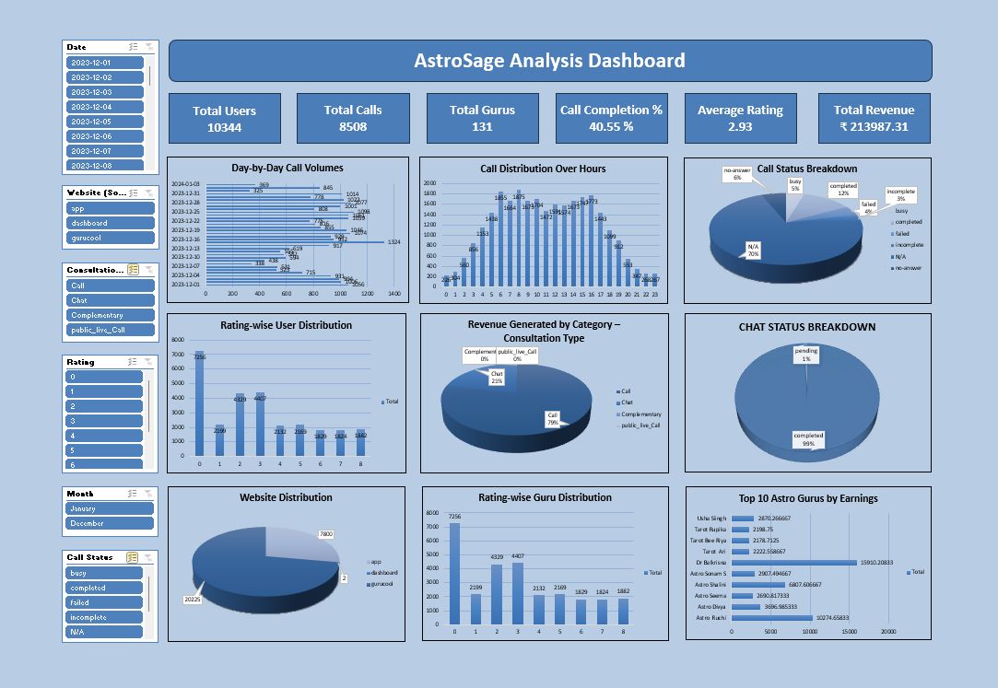

- How would you allocate a 1 crore rupee investment to optimize operational efficiency, enhance customer satisfaction, and boost profitability, and what analysis-based recommendations would you offer to support this?
[you have to give bullet pointers to answer this question]

Ans:

- 45% – Technology Upgrade (₹45 lakhs)
  - Upgrade call center infrastructure to reduce failed, busy, and no-answer calls.
  - Introduce AI chatbots to handle basic user queries and reduce call load.
  - Improve call routing and add alternative communication options to ensure smoother connectivity during peak hours.
  - This investment is justified as call completion rate is low (40.55%) and system failures impact customer satisfaction.
- 30% – Training & Hiring New Agents (₹30 lakhs)
  - Hire experienced and senior Astro Gurus to handle complex user queries.
  - Provide focused training to existing agents based on low rating patterns.
  - Improve response clarity and session handling to increase customer satisfaction and ratings.
  - This is supported by rating analysis showing that over 70% of users gave low ratings.
- 25% – Marketing & Customer Engagement (₹25 lakhs)
  - Offer free trial sessions, discounts, and membership plans to retain users.
  - Conduct live sessions or promotional events to attract new users.
  - Re-engage dissatisfied users through offers and feedback-based improvements.
  - This helps reduce churn and increase repeat usage.

Analysis-Based Recommendations:
- Peak-hour and peak-day analysis shows uneven call load, justifying investment in technology and staffing.
- Low call completion rate highlights the need for better infrastructure.
- Rating distribution indicates service quality gaps that can be addressed through training.
- Chat service shows higher satisfaction, supporting automation and workflow improvements.

Conclusion:
This project analyses call center performance using historical data to evaluate operations, customer satisfaction, agent efficiency, and revenue impact. Objective analysis identified key challenges such as low call completion rates, peak-hour workload imbalance, and high customer dissatisfaction, while also highlighting Chat service as the most satisfying interaction channel.
Subjective insights translated these findings into practical recommendations, including workforce optimisation, targeted training, technology upgrades, and customer engagement strategies. The proposed investment plan focuses on improving efficiency, service quality, and profitability. Overall, this data-driven approach supports informed decision-making and sustainable improvement in call center performance.

By: Prajyot Naik
DS Oct 2025 Batch

